ASSIGNMENT-06

1.Write a Java program to calculate the final grade of a student based on their scores in assignments, midterm, and final exam. Variables: String studentName, int assignmentScore, int midtermScore, int finalExamScore, String finalGrade

Test case // Input studentName = "Alice"; assignmentScore = 85; midtermScore = 78; finalExamScore = 92; // Expected Output: Alice's final grade is B.

public class CalculateFinalGrade {

public static void main(String[] args) {

String studentName = "Alice";

int assignmentScore = 85;

int midtermScore = 78;

int finalExamScore = 92;

String finalGrade;

int averageScore = (assignmentScore + midtermScore + finalExamScore) / 3;

if (averageScore >= 90) {

finalGrade = "A";

} else if (averageScore >= 80) {

finalGrade = "B";

} else if (averageScore >= 70) {

finalGrade = "C";

} else if (averageScore >= 60) {

finalGrade = "D";

} else {

finalGrade = "F";

}

System.out.println(studentName + "'s final grade is " + finalGrade + ".");

}

}

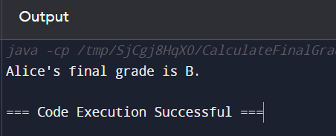

2. Write a Java program to calculate the mileage of a car given the distance traveled and fuel consumed. Variables: String carModel, double distanceTraveled, double fuelConsumed, double mileage

Test Case: // Input carModel = "Toyota Camry"; distanceTraveled = 300; fuelConsumed = 15; // Expected Output: The mileage of Toyota Camry is 20.0 miles per gallon.

public class Car {

private String model;

private double distanceTraveled;

private double fuelConsumed;

public Car(String model, double distanceTraveled, double fuelConsumed) {

this.model = model;

this.distanceTraveled = distanceTraveled;

this.fuelConsumed = fuelConsumed;

}

public double calculateMileage() {

return distanceTraveled / fuelConsumed;

}

public static void main(String[] args) {

Car toyotaCamry = new Car("Toyota Camry", 300, 15);

System.out.println("The mileage of " + toyotaCamry.model + " is " + toyotaCamry.calculateMileage() + " miles per gallon");

}

}

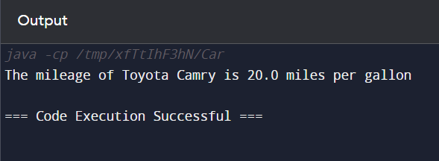

3. Write a Java program to calculate the fine for overdue books in a library. The fine is calculated based on the number of days overdue. Variables: String bookTitle, int daysOverdue, double finePerDay, double totalFine

Test Case: // Input bookTitle = "Harry Potter"; daysOverdue = 5; finePerDay = 0.50; // Expected Output: The fine for Harry Potter is $2.50.

import java.util.Scanner;

public class LibraryFineCalculator {

public static void main(String[] args) {

Scanner scanner = new Scanner(System.in);

System.out.print("Enter the book title: ");

String bookTitle = scanner.nextLine();

System.out.print("Enter the number of days overdue: ");

int daysOverdue = scanner.nextInt();

System.out.print("Enter the fine per day: ");

double finePerDay = scanner.nextDouble();

double totalFine = calculateFine(daysOverdue, finePerDay);

System.out.println("The fine for " + bookTitle + " is $" + totalFine);

scanner.close();

}

public static double calculateFine(int daysOverdue, double finePerDay) {

return daysOverdue \* finePerDay;

}

}

